Ahmad Alomari

Dipen R Bhuva

Ryhan Uddin

Submitted on: 7th Dec, 2023

Submitted on: 7th Dec, 2023

**HUMAN RESOURCE MANAGEMENT PANEL DEVELOPMENT PLAN FOR CLEVELAND STATE UNIVERSITY**

***HUMAN RESOURCE MANAGEMENT PANEL DEVELOPMENT PLAN FOR CLEVELAND STATE UNIVERSITY***

**Table of Contents**

**1. Introduction** 5

**1.1. Purpose and Scope** 5

**1.2. Product Overview** 5

**1.2.1 Major software functions and use scenarios** 5

**1.3. Structure of the Document** 7

**2. Project Management Plan** 8

**2.1. Project Organization** 8

**2.2. Lifecycle Model Used** 8

**2.3. Risk Analysis** 8

**2.3.1 Project Risks** 9

**2.3.2 Risk Table** 9

**2.3.3 Overview of Risk Mitigation, Monitoring, Management (RM3)** 9

**2.4. Hardware and Software Resource Requirements** 10

**2.5. Deliverables and schedule** 10

**2.5.1 Project task set** 11

**2.5.2 Functional decomposition** 12

**2.5.3 Task network** 14

**2.5.4 Timeline chart** 14

**2.5.5 Schedule compliance** 15

**3. Requirement Specifications** 16

**3.1. Stakeholders for the system** 16

**3.2. Use cases** 16

**3.2.1. Graphic use case model** 17

**3.2.2. Textual Description for Use Cases** 19

**3.3. Rationale for the use case model** 25

**3.4. Non-functional requirements** 26

**4. Architecture** 27

**4.1. Architectural style used** 27

**4.2. Architectural model (includes components and their interactions)** 28

**4.3. Technology, software, and hardware used** 29

**4.4. Rationale for your architectural style and model** 29

**5. Design** 30

**5.1. User Interface design** 30

**5.1.1 Description of the user interface** 31

**5.1.2 Interface design rules** 33

**5.2. Components design** 34

**5.2.1 Presentation Layer** 34

**5.2.2 Business Logic Layer** 35

**5.2.3 Data Access Layer** 35

**5.2.4 Physical Layer** 36

**5.3. Database design** 37

**5.3.1 Relationships** 38

**5.3.2 Complete Data Model** 38

**5.3.3 Data Dictionary** 39

**5.4. Rationale for your detailed design models** 41

**5.5. Traceability from requirements to detailed design models** 42

**6. Test Management** 44

**6.1. A complete list of system test cases** 44

**6.2. Traceability of test cases to use cases** 53

**6.3. Techniques used for test case generation** 55

**6.4. Test results and assessments:** 56

**6.5. Defects reports** 62

**7. Conclusion** 63

**7.1. Outcomes of the project** 63

**7.2. Lessons learned** 63

**7.3. Future development** 64

**References** 64

**List of Figures**

Figure 1. HRM software development Gantt chart 14

Figure 2. HRM software development timeline 15

Figure 3.Use case diagram 17

Figure 4. Sequence diagram of view profile (Actor: Employee) 18

Figure 5. Sequence diagram of enroll employee (Actor: HR Manager) 19

Figure 6. Architectural Design 28

Figure 7. Home Page 31

Figure 8. Program Tab 31

Figure 9. Professional Development Page 32

Figure 10. Event Calendar Feature 33

Figure 11. Class diagrams for Presentation Layer 34

Figure 12. Class diagrams for Business Logic Layer 35

Figure 13. Class diagrams for Data Access Layer 36

Figure 14. Class Diagram for Physical Layer 37

Figure 15. Database Design Model 38

**List of Tables**

Table 1: Risk Table 10

Data Dictionary 40

TC001 45

TC002 45

TC003 45

TC004 46

TC005 46

TC006 46

TC007 46

TC008 47

TC009 47

TC0010 47

TC0011 47

TC0012 48

TC0013 48

TC0014 48

TC0015 48

TC0016 49

TC0017 49

TC0018 49

TC0019  49

TC0020 49

TC0021 50

TC0022 50

TC0023 50

TC0024 50

TC0025 51

TC0026 51

TC0027 51

TC0028 51

TC0029 51

TC0030 52

TC0031 52

TC0032 52

TC0033 52

TC0034 53

TC0035 53

TC0036 53

# **1. Introduction**

The Human Resource Management Panel (HRM) project for Cleveland State University represents a pivotal initiative aimed at modernizing and enhancing the university's human resources management system. In an era of increasing complexity and innovation, the need for an efficient and streamlined HR system has become imperative. This project seeks to address this need by developing a cutting-edge software solution that will revolutionize HR processes, elevate data management, and ultimately contribute to the university's operational excellence.

## **1.1. Purpose and Scope**

The objective of the Human Resource Management Panel project is to develop a comprehensive and user-friendly software solution to streamline HR operations, enhance employee data management, and improve overall efficiency within Cleveland State University's HR department. The panel will serve as a centralized platform to facilitate professional development, leadership training, team development, and provide access to critical HR services and information.

## **1.2. Product Overview**

The primary goals of the HRM panel software encompass streamlining Cleveland State University’s HR processes, enhancing employee management, optimizing talent acquisition and retention, facilitating data-driven decision-making, ensuring compliance with legal regulations, and fostering a positive organizational culture. Objectives include the development of an intuitive user interface, efficient data management, real-time analytics, and seamless integration with existing HR systems.

### **1.2.1 Major software functions and use scenarios**

* Professional Development:
* User-friendly interface for employees to access professional development opportunities.
* Integration with event calendars to promote and track training sessions, workshops, and seminars.
* Online registration and tracking of employee participation in professional development programs.
* Scenario: Employees can access training materials and resources for ongoing professional development.
* Leadership Training:
* Access to leadership training resources and materials.
* Enrollment and tracking of employees in leadership development programs.
* Interactive modules for leadership skill development.
* Scenario: Leaders can monitor the progress of their team members and provide necessary support.
* Team Development:
* Collaboration tools for teams within the university.
* Access to team-building resources and activities.
* Integration with HR processes to support team development initiatives.
* Scenario: Team members can communicate and share resources through the platform.
* About Page:
* Mission statement and overview of HRM's role within the university.
* Information about HR departments, units, and their functions.
* Details on HR services and programs offered.
* Scenario: A new university employee visits the HRM About Page to read the mission statement, understand HRM's role, explore department functions, and learn about the services and programs provided by the HR department.
* Benefits:
* Access to comprehensive employee benefits information.
* Online enrollment and management of benefits programs.
* Information on medical plans, dental plans, reimbursement accounts, retirement plans, life insurance, disability programs, and tuition reimbursement.
* Scenario: Employees can easily access and manage their comprehensive benefits information, including the HRM Panel's user-friendly online platform.
* Compensation:
* Access to information on compensation policies and structures.
* Salary range details and performance appraisal programs.
* Support for job design related to reorganization and restructuring.
* HR Partners:
* Information on HR Business Partners and Talent Acquisition Partners.
* Services related to change management, organizational design, employee engagement, strategic workforce planning, and performance management.
* Learning and Organizational Development:
* Access to professional development opportunities, management, and leadership programs.
* Information on university-wide New Hire Orientation program.
* Integration with event calendars for training scheduling.
* Careers:

Job posting and application functionality for career opportunities within the university.

* Resume submission and tracking for applicants.
* Integration with HR processes for efficient hiring.
* Event Calendars:
* Comprehensive event calendars for HR-related events, workshops, and training sessions.
* Registration and attendance tracking for events.
* Search Engine:
* Robust search functionality to quickly locate HR information, policies, forms, and resources.
* Facilitates easy navigation and retrieval of relevant content.

## **1.3. Structure of the Document**

The document is structured to provide a comprehensive overview of the Human Resource Management Panel (HRM) project for Cleveland State University. The introduction sets the stage by highlighting the initiative's significance in modernizing the university's human resources management system. Following the introduction, the Project Management Plan outlines the strategies, schedules, and resources employed to ensure the project's successful execution. Requirement Specifications delve into the detailed objectives of the HRM Panel, specifying the functionalities it aims to deliver, with a focus on streamlining HR operations and improving data management. The Architecture section provides insights into the underlying structure and technological framework of the software solution. Moving forward, the Design section elaborates on the user interface and experience, ensuring a user-friendly and efficient HR platform. Test Management details the rigorous testing processes implemented to guarantee the reliability and effectiveness of the HRM Panel. Finally, the Conclusions section summarizes key findings, outcomes, and future considerations, offering a holistic understanding of the project's development and its potential impact on Cleveland State University's operational excellence.

# **2. Project Management Plan**

The Project Management Plan serves as the strategic blueprint for the successful execution of the HRM project. This comprehensive plan encompasses various critical elements, including project organization and the lifecycle model adopted, to ensure clarity, efficiency, and adaptability throughout the development process. Through a well-defined project organization, roles and responsibilities are delineated to promote effective collaboration among team members, fostering accountability and streamlined communication. Simultaneously, the project embraces an iterative and incremental lifecycle model, emphasizing flexibility and responsiveness to changing requirements. By employing an agile approach, the project team aims to deliver incremental functionalities, enabling continuous feedback loops and ensuring that the HRM Panel aligns closely with the evolving needs of the university's HR department. This Project Management Plan lays the foundation for a dynamic and collaborative development process, ultimately contributing to the successful realization of a cutting-edge HR solution for Cleveland State University.

## **2.1. Project Organization**

The project organization for the Human Resource Management Panel (HRM) at Cleveland State University is meticulously structured to ensure effective coordination and communication. The team comprises skilled professionals with diverse expertise, including project managers, software developers, UI/UX designers, testers, and domain experts from the university's HR department. The roles and responsibilities of each team member are clearly defined to foster accountability and efficient collaboration. Regular communication channels, such as team meetings and project management tools, are established to facilitate seamless information flow and quick issue resolution. Stakeholders from the university's HR department are actively involved in the decision-making process to align the project with the department's specific needs and objectives.

## **2.2. Lifecycle Model Used**

The HRM project adopts an iterative and incremental lifecycle model to ensure flexibility and responsiveness to evolving requirements. The use of an agile development approach allows for continuous feedback loops and regular updates, promoting adaptability to changes in project scope or priorities. This iterative model facilitates the phased development of features, ensuring that key functionalities are delivered incrementally, tested, and refined. This approach not only accelerates the development process but also enables the project team to incorporate feedback from stakeholders at various stages, ensuring that the final product aligns closely with the evolving needs of Cleveland State University's HR department.

## **2.3. Risk Analysis**

In this section, we present a comprehensive risk management plan tailored for the Human Resource Management Panel (HRM) project, where the integration of PHP, JavaScript, WordPress, and MySQL forms the core technological framework. Managing risks is pivotal to the success of any project, especially one as multifaceted as an HRM panel that involves the strategic amalgamation of diverse technologies. This plan outlines a proactive approach to identify, assess, and mitigate potential risks that could impact project timelines and overall project objectives. By addressing these risks early on and establishing effective risk mitigation strategies, we aim to ensure a smoother development process and successful implementation of the HRM panel, meeting the project goals and requirements.

### **2.3.1 Project Risks**

* Technical Skill Gaps: Description: Inadequate technical skills within the team regarding PHP, JavaScript, WordPress, or MySQL.
* Probability: Medium, Impact: High, RM3 Pointer: 6
* Integration Challenges: Probability: Difficulty in integrating various technologies seamlessly.
* Probability: High, Impact: High, RM3 Pointer: 9
* Security Vulnerabilities: Potential security breaches due to inadequately secured code or configurations.
* Probability: Medium, Impact: High, RM3 Pointer: 7
* Scope Creep: Uncontrolled expansion of project scope, affecting timelines and resources.
* Probability: Medium, Impact: Medium, RM3 Pointer: 4

### **2.3.2 Risk Table**

Table 1. Risk Table

|  |  |  |  |
| --- | --- | --- | --- |
| **Risk Name** | **Probability** | **Impact** | **RM3 Pointer** |
| Technical Skill Gaps | Medium | High | 6 |
| Integration Challenges | High | High | 9 |
| Security Vulnerabilities | Medium | High | 7 |
| Scope Creep | Medium | Medium | 4 |

### **2.3.3 Overview of Risk Mitigation, Monitoring, Management (RM3)**

The Risk Management, Mitigation, Monitoring (RM3) Plan outlines the strategies and procedures for mitigating, monitoring, and managing risks throughout the project lifecycle for the HRM panel project. The primary objective of this plan is to ensure that risks are proactively addressed to minimize their impact on the project's success.

* **Technical Skill Gaps:**
* Description: Inadequate technical skills within the team regarding PHP, JavaScript, WordPress, or MySQL.
* Mitigation: We will conduct regular skills assessments and provide training or access to external expertise as needed.
* Monitoring: Monitor team progress and skills development.
* Responsibility: All of the team members.
* **Integration Challenges:**
* Description: Difficulty in integrating various technologies seamlessly. The challenge will be in ensuring the smooth flow of data between the front-end (JavaScript) and back-end (PHP, MySQL).
* Mitigation: We will Outline the specific steps and processes involved in integrating these technologies. Also, we will define how data will be passed between PHP, JavaScript, WordPress, and MySQL. Moreover, we will conduct tests at each step of integration, thoroughly to ensure that data is correctly passed and displayed.
* Monitoring: Regularly review integration progress and test results.
* Responsibility: All of the team members.
* **Security Vulnerabilities:**
* Description: Potential security breaches may occur due to inadequately secured code or configurations, making the website vulnerable to attacks such as SQL injection or cross-site scripting (XSS).
* Mitigation: We will use prepared statements in PHP to prevent SQL injection attacks when interacting with the MySQL database. Also, we will validate user input to ensure it meets the expected format and doesn't contain malicious code. Moreover, we will implement input validation on the client using JavaScript to prevent sending incorrect or malicious data to the server.
* Monitoring: Regularly assess the security posture and conduct vulnerability scans.
* Responsibility: All of the team members.
* **Scope Creep**
* Description: Uncontrolled expansion of project scope, affecting timelines and resources.
* Mitigation: We will develop a clearly defined change control process that outlines how changes to the project scope will be evaluated, approved, and implemented.
* Monitoring: Regularly review and approve scope change requests.
* Responsibility: All of the team members.

### **2.4. Hardware and Software Resource Requirements**

The successful implementation of the Human Resource Management Panel (HRM) project at Cleveland State University relies on a robust combination of hardware and software resources. The chosen technological framework centers around the integration of PHP, JavaScript, WordPress, and MySQL. On the front-end, JavaScript is employed to craft a responsive and user-friendly interface, ensuring an optimal user experience for HR professionals and employees. The back-end leverages PHP for server-side scripting and MySQL as the relational database management system, providing a secure and scalable foundation for data storage and retrieval. The hardware requirements include servers capable of hosting the web application efficiently, ensuring reliable performance and responsiveness. Additionally, the software infrastructure encompasses the utilization of WordPress, a versatile content management system, to facilitate content creation, publication, and management. These combined hardware and software resources form a cohesive and powerful ecosystem, laying the groundwork for the development of an advanced HRM solution tailored to meet the specific needs of Cleveland State University.

## **2.5. Deliverables and schedule**

This section presents an outline of the project tasks and the timeline overview of the whole software development process.

### **2.5.1 Project task set**

Developing a Human Resource Management Panel (HRM) for Cleveland State University to streamline HR operations is a significant undertaking. Below is a set of project tasks tailored to this specific project:

* **Project Initiation**
* Define the project's scope, including the specific functionalities and features required to streamline HR operations.
* Identify key stakeholders, both within the HR department and across other university departments, to ensure their needs and expectations are considered.
* Create a comprehensive project charter that outlines the project's goals, objectives, timelines, and resources, obtaining formal approval to proceed.
* **Needs Assessment and Analysis**
* Conduct an in-depth needs assessment in collaboration with the HR team to gain a thorough understanding of their existing processes and challenges.
* Analyze the current HR workflows, identifying pain points, bottlenecks, and areas where automation can significantly improve efficiency.
* **Requirements Gathering and Documentation**
* Engage in extensive discussions and workshops with HR professionals to gather highly detailed functional requirements for the new HRM software.
* Document these requirements meticulously, ensuring clarity, specificity, and alignment with the university's HR goals.
* Prioritize requirements based on their criticality and the impact they will have on HR operations.
* **System Design and Architecture**
* Develop a robust system architecture plan that outlines the software's structure, including databases, interfaces, and integration points with other university systems.
* Design an intuitive and user-friendly UI for the software to enhance user adoption and satisfaction.
* Establish data models that govern how employee information and HR related data will be structured and accessed.
* **Development and Testing**
* Execute the development phase, building the HRM software based on the previously defined requirements and design specifications.
* Implement rigorous testing procedures, including unit testing and integration testing, to identify and rectify any software defects or issues.
* **User Acceptance Testing (UAT)**
* Collaborate closely with HR team members to conduct thorough user acceptance testing (UAT), ensuring that the software aligns with their specific needs and expectations.
* Actively gather feedback from HR personnel during UAT and make necessary adjustments to enhance the software's effectiveness and user experience.
* **Data Migration**
* Plan and execute a comprehensive data migration strategy, transferring historical employee data from existing systems to the new HRM software.
* Conduct data integrity checks to ensure that all transferred data is accurate and complete, with minimal disruption to ongoing HR processes.
* **Deployment and Training**
* Carefully plan and execute the production deployment of the HRM software, ensuring that all technical and logistical requirements are in place.
* Provide tailored training sessions and user manuals to HR staff, enabling them to utilize the new software effectively and confidently in their daily operations.
* **Post-Deployment Support**
* Establish an efficient system for providing ongoing technical support, addressing inquiries, and troubleshooting issues that may arise.
* Continuously monitor system performance and gather user feedback, using this information to guide improvements and updates.
* Maintain a strong focus on security and compliance to safeguard sensitive HR data, remaining vigilant regarding changes in regulations and university policies.

### **2.5.2 Functional decomposition**

This segment describes the functional breakdown that is tailored to Cleveland State University's HRM software development project, highlighting the customization and alignment with the university's unique requirements and goals.

* **Project Initiation**
* Define project scope and objectives.
* Create a project charter tailored to university's needs.
* Obtain formal approval from university leadership.
* **Needs Assessment and Analysis**
* Conduct in-depth needs assessment with university HR team.
* Analyze current HR processes specific to the university.
* Identify university-specific pain points and bottlenecks.
* Explore opportunities for customization to meet the requirements.
* **Requirements Gathering and Documentation**
* Collaborate closely with university HR professionals to gather highly detailed functional requirements.
* Document requirements for HR processes, compliance, and reporting.
* Prioritize requirements based on university’s unique needs and goals.
* **System Design and Architecture**
* Develop a customized system architecture plan considering Cleveland State University’s unique data flow and integration requirements.
* Create custom wireframes and UI designs tailored to university’s branding and user preferences.
* Establish data models customized for university’s HR data.
* **Development and Testing**
* Develop HRM software features with university-specific functionality.
* Implement robust security measures to protect sensitive HR data.
* Conduct rigorous testing, including unit testing, integration testing, and compatibility testing.
* Address defects or issues with a focus on meeting university’s requirements.
* **User Acceptance Testing (UAT)**
* Engage Cleveland State University HR team actively in UAT to validate software customization.
* Develop UAT test cases aligned with HR processes.
* Conduct UAT sessions with university HR personnel.
* Gather feedback specific to university’s HR needs.
* Make necessary customizations to meet the requirements.
* **Data Migration**
* Plan and execute data migration strategy tailored to university’s historical HR data.
* Verify data integrity and accuracy post-migration with a focus on university-specific data requirements.
* Ensure minimal disruption to ongoing HR processes during migration.
* **Deployment and Training**
* Plan and execute production deployment aligned with Cleveland State University’s it infrastructure and policies.
* Provide specialized user training tailored to university’s HR staff.
* Develop user manuals and documents customized for university HR operations.
* **Post-Deployment Support and Monitoring**
* Establish ongoing technical support specific to university’s HRM software.
* Continuously monitor system performance to ensure it meets university’s requirements.
* Gather and address user feedback tailored to the university's HR operations.
* Maintain strong focus on security and compliance to protect sensitive HR data.
* Plan for software enhancements and updates that align with university’s evolving HR needs and university policies.

### **2.5.3 Task network**

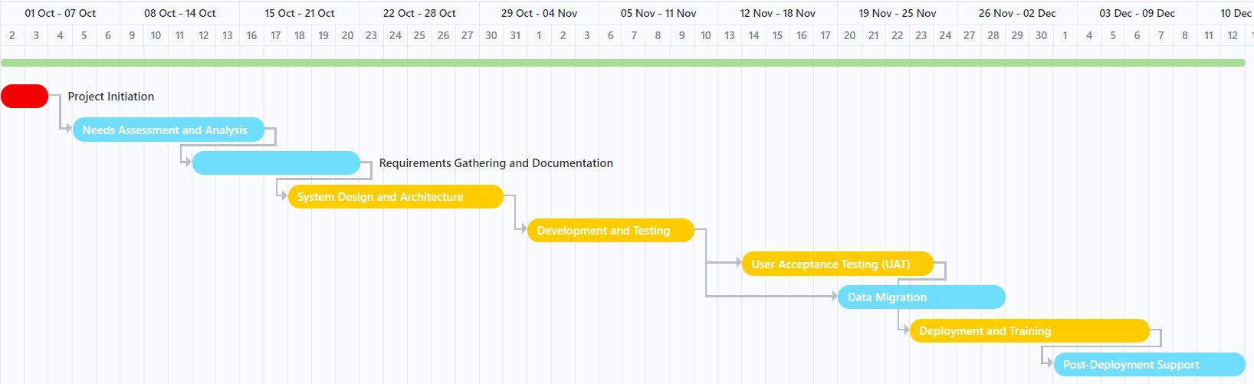Following Gantt chart show (Figure 1) the task network that delineates each individual tasks of the HRM software development process sequentially and their dependencies.

Figure 1. HRM software development Gantt chart

### **2.5.4 Timeline chart**

Following table shows the whole timeline of the Cleveland state university HRM software development process. The tasks are defined in the second column which is also highlighted with dependency markers. The column is followed by individual task due dates and it is followed by the priority level of each tasks. The right most corner provides the legends for the task priority levels defined in low, medium, high and urgent. From the table it is observable that the development period extends from early October to mid-December. The development process strictly adheres to the deadline, which is 7th December 2023. Therefore, the full deployment process is designed to be finished by 6th December.

Figure 2. HRM software development timeline

Out of all the tasks, the development and testing period is the longest as it involves rigorous testing and deployment through trial and errors. From the table it is evident that the post-deployment support extends even after the deployment due date.

### **2.5.5 Schedule compliance**

The following segment describes the schedule compliance phases of monitoring and reporting supervised through precise control flow of each tasks.

* **Monitoring and Reporting Mechanisms:**
  + Regular status meetings with stakeholders to monitor progress.
  + Weekly progress updates on key tasks.
  + Daily tracking of critical activities.
  + Bi-weekly project status reports to stakeholders.
  + Comprehensive reports at key milestones.
* **Controlling Mechanisms:**
  + Continuous alignment with defined project scope and objectives.
  + Immediate escalation of scope changes or deviations.
  + Ongoing communication and collaboration with university HR professionals.
  + Timely identification and resolution of issues during testing phases.
  + Rapid customization based on specific feedback.
  + Stringent data integrity checks and verification post-migration.
  + Ensuring user training aligns with university HR operations.
  + Continuous system performance monitoring to address any issues promptly.

In conclusion, the development of a comprehensive Human Resource Management Panel (HRM) for Cleveland State University is a complex yet essential undertaking. This project plan serves as a guiding framework that prioritizes the alignment of the HRM software with Cleveland State University's specific requirements, while actively managing risks and adhering to a well-structured project schedule. The successful implementation of this plan will result in a tailored HRM solution that significantly enhances HR operations, ultimately benefiting the university as a whole. It is with great dedication and commitment that we embark on this journey to bring this vital project to fruition.

# **3. Requirement Specifications**

## **3.1. Stakeholders for the system**

User profiles refer to the individuals or roles that will interact with the HRM software. In this context, user profiles might include HR managers, employees, administrators, and potentially other stakeholders. Each user profile may have different levels of access and permissions within the system.

* HR Manager: This user profile may have access to all HR data objects, allowing them to view and manage employee profiles, professional development records, compensation details, and more.
* Employee: An employee may have limited access, primarily to view their own employee profile, benefits, and professional development history.
* Administrator: Administrators may have elevated permissions to manage user accounts, system settings, and perform data backups.

## **3.2. Use cases**

This segment outlines the overview of the use cases of the HRM software. It takes three actors into consideration: Administrator, HR Manager and Employee. The use cases are detailed in the following figure.

### **C:\Users\Bickey\My Drive\Academic\CSU\Software Engineering\Project\Software Design Specification\SDS use case diagram.jpg3.2.1. Graphic use case model**

Figure 3.Use case diagram

Based on these use cases we can outline the sequence diagrams as well. Following figure (figure 4) shows the sequence diagram of the use case **View Profile** (Actor: Employee) and the following figure (figure 5) shows the sequence diagram of **Enroll Employee** (Actor: HR Manager).

Figure 4. Sequence diagram of view profile (Actor: Employee)

Figure 5. Sequence diagram of enroll employee (Actor: HR Manager)

### **3.2.2. Textual Description for Use Cases**

Use-cases describe specific actions or tasks that users can perform within the HRM software. Each use-case typically includes a description of the task, the actors involved (user profiles), and the expected outcome. Use cases are discussed below:

* Use-Case 1: Modify Employee
* Actor: Employee
* Description: An employee can update their personal information, such as contact details, by logging into the HRM system.
* Outcome: The employee's profile is updated with the new information.
* Use-Case 2: Enroll Employe
* Actor: HR Manager
* Description: An HR manager can enroll an employee in a professional development program, specifying program details and employee information.
* Outcome: The employee is successfully enrolled in the program, and program details are recorded.
* Use-Case 3: Mange Benefits and Compensation
* Actor: HR Manager
* Description: HR managers can review an employee's compensation details, including base salary, bonus, and allowances.
* Outcome: HR managers can adjust compensation if necessary.
* Use-Case 4: Add Account
* Actor: Administrator
* Description: The administrator initiates the process to add a new user account to the system, providing necessary details such as username, password, and role assignment.
* Outcome: A new user account is successfully created, allowing the assigned user to log in and access relevant system functionalities.
* Use Case 5: Modify Account
* Actor: Administrator
* Description: The administrator modifies existing user account details, such as updating the username, password, or role assignment.
* Outcome: The user account is successfully updated with the modified information, ensuring accurate and secure user management.
* Use Case 6: Delete Account
* Actor: Administrator
* Description: The administrator initiates the deletion of a user account, removing access for the specified user from the system.
* Outcome: The user account is successfully deleted, revoking system access for the specified user.
* Use Case 7: Add Privilege
* Actor: Administrator
* Description: The administrator adds a new privilege or access level to a user account, expanding their capabilities within the system.
* Outcome: The user now possesses additional privileges, enabling them to perform specific actions or access certain features.
* Use Case 8: Modify Privilege
* Actor: Administrator
* Description: The administrator modifies the privileges assigned to a user account, adjusting their access levels within the system.
* Outcome: The user's privileges are successfully updated, reflecting the changes made by the administrator.
* Use Case 9: Delete Privilege
* Actor: Administrator
* Description: The administrator removes a specific privilege from a user account, limiting their access within the system.
* Outcome: The user's privileges are successfully modified, restricting their capabilities based on the removed privilege.
* Use Case 10: Access Database
* Actor: Administrator
* Description: The administrator accesses the system's database to retrieve or review information, ensuring data integrity and security.
* Outcome: The administrator successfully interacts with the database, retrieving the required information for system management.
* Use Case 11: Maintain Database
* Actor: Administrator
* Description: The administrator performs maintenance tasks on the system database, such as backups, updates, or data cleansing, to ensure optimal database performance.
* Outcome: The database is successfully maintained, contributing to the system's overall stability and reliability.
* Use Case 12: Respond to Queries
* Actor: Administrator
* Description: The administrator responds to queries from system users, addressing concerns, providing assistance, or offering information related to system functionalities.
* Outcome: Users receive timely and accurate responses, enhancing their understanding and utilization of the system.
* Use Case 13: View Jobs
* Actor: Employee
* Description: Employees can explore available job opportunities within the university. This includes accessing a list of current job postings, reviewing job descriptions, and understanding the application process for potential career growth.
* Outcome: Employees gain insights into available career opportunities and make informed decisions about potential job applications.
* Use Case 14: View Development Program
* Actor: Employee
* Description: Employees can access information about professional development programs available within the university. This involves viewing details about training sessions, workshops, and seminars aimed at enhancing their skills and knowledge.
* Outcome: Employees can make informed decisions about participating in relevant professional development programs to support their career growth.
* Use Case 15: Update Profile
* Actor: Employee
* Description: Employees have the ability to update their personal and professional information in the system. This includes details such as contact information, educational qualifications, and work experience.
* Outcome: Employees ensure that their profile information is accurate and up-to-date, facilitating effective communication and HR processes.
* Use Case 16: View Profile
* Actor: Employee
* Description: Employees can access and review their own comprehensive profiles within the HRM system. This includes personal details, employment history, and any certifications or training completed.
* Outcome: Employees gain a holistic view of their professional information, supporting self-assessment and career planning.
* Use Case 17: Access Calendar Event
* Actor: Employee
* Description: Employees can view and access the HR-centric event calendar, which includes important dates such as training sessions, workshops, and other HR-related events.
* Outcome: Employees stay informed about upcoming HR events and can plan their schedules accordingly, fostering engagement and participation.
* Use Case 18: View Benefits and Compensation
* Actor: Employee
* Description: Employees can review details related to their benefits and compensation, encompassing information on medical plans, dental coverage, retirement benefits, and salary details.
* Outcome: Employees gain a clear understanding of their total compensation package, promoting transparency and awareness of available benefits.
* Use Case 19: Contact HR
* Actor: Employee
* Description: Employees have the ability to initiate communication with the HR department. This includes making inquiries, seeking assistance, or reporting HR-related issues.
* Outcome: Employees can effectively communicate with the HR team, facilitating prompt resolution of queries and promoting a supportive work environment.
* Use Case 20: Delete Employee
* Actor: HR Manager
* Description: The HR Manager initiates the process to remove an employee's record from the system, ensuring that associated data, such as personal details and employment history, is securely deleted.
* Outcome: The employee's record is successfully removed from the system, and relevant data is updated accordingly.
* Use Case 21: View Employee Record
* Actor: HR Manager
* Description: The HR Manager accesses the system to view a comprehensive record of an employee, including personal information, job history, and performance evaluations.
* Outcome: The HR Manager gains valuable insights into the employee's profile, facilitating informed decision-making and HR processes.
* Use Case 22: Post Job
* Actor: HR Manager
* Description: The HR Manager creates and posts a job opening within the system, specifying details such as job title, responsibilities, and qualifications.
* Outcome: The job posting becomes visible to potential candidates, initiating the recruitment process for the vacant position.
* Use Case 23: Modify Job
* Actor: HR Manager
* Description: The HR Manager updates information related to an existing job posting, such as modifying job requirements, responsibilities, or qualifications.
* Outcome: The modified job details are reflected in the system, ensuring accuracy and alignment with current hiring needs.
* Use Case 24: Delete Job
* Actor: HR Manager
* Description: The HR Manager initiates the removal of a job posting from the system, indicating that the position is no longer available.
* Outcome: The job posting is successfully deleted, and associated data is updated accordingly.
* Use Case 25: Create Program Development
* Actor: HR Manager
* Description: The HR Manager initiates the creation of a program development initiative, specifying details such as goals, objectives, and target audience.
* Outcome: The new program development initiative is added to the system, and relevant stakeholders are informed.
* Use Case 26: Modify Program Development
* Actor: HR Manager
* Description: The HR Manager makes changes to an existing program development initiative, such as adjusting goals, updating content, or modifying the target audience.
* Outcome: The modifications are successfully implemented, ensuring the program development aligns with evolving requirements.
* Use Case 27: Delete Program Development
* Actor: HR Manager
* Description: The HR Manager initiates the removal of a program development initiative from the system, indicating that it is no longer relevant or necessary.
* Outcome: The program development initiative is successfully deleted, and associated data is updated accordingly.
* Use Case 28: Contact Admin
* Actor: HR Manager
* Description: The HR Manager utilizes the system to contact the system administrator for support, assistance, or to report issues.
* Outcome: The system administrator is notified, and necessary actions are taken to address the HR Manager inquiries or concerns.
* Use Case 29: Create Event
* Actor: HR Manager
* Description: The HR Manager initiates the creation of a new event within the system, specifying details such as event type, date, venue, and participants.
* Outcome: The new event is successfully added to the system, and relevant stakeholders are informed, facilitating event planning and coordination.
* Use Case 30: Respond to Queries
* Actor: HR Manager
* Description: The HR manager responds to queries from system users, addressing concerns, providing assistance, or offering information related to system functionalities.
* Outcome: Users receive timely and accurate responses, enhancing their understanding and utilization of the system.

## **3.3. Rationale for the use case model**

The use case model for the Human Resource Management Panel (HRM) project at Cleveland State University is strategically designed to provide a clear and comprehensive representation of system functionalities and interactions. Several key rationales underpin the use case model:

* Functional Clarity: The use case model serves as a visual and conceptual roadmap, offering stakeholders a clear understanding of how the HRM Panel will function in different scenarios. By identifying and illustrating specific use cases, it provides a detailed overview of the system's capabilities and functionalities.
* Stakeholder Alignment: Use cases are defined based on the needs and expectations of various stakeholders, ensuring that the system aligns closely with their requirements. This alignment is crucial for fostering stakeholder buy-in and engagement throughout the development process.
* Requirements Validation: The use case model serves as a tool for validating system requirements. By mapping out different use cases, it becomes possible to ensure that the system addresses diverse scenarios and meets the identified needs of HR professionals, employees, and other stakeholders.
* Scope Definition: The use case model helps in clearly defining the boundaries and scope of the HRM Panel. It identifies the specific interactions and functionalities within the system, preventing scope creep and ensuring that the project stays focused on its primary objectives.
* Development Guidance: Use cases provide valuable guidance for the development team by detailing the expected interactions and functionalities. They offer a foundation for creating test cases, designing user interfaces, and implementing the necessary features.
* User Experience Considerations: By outlining different use cases, the model aids in considering the user experience from end to end. It ensures that the HRM Panel not only meets functional requirements but also provides an intuitive and efficient experience for end-users.
* Change Management: The use case model facilitates change management by allowing stakeholders to visualize and understand the impact of proposed changes on different aspects of the system. This aids in making informed decisions about modifications or enhancements.

## **3.4. Non-functional requirements**

The successful deployment and operation of the HRM panel at Cleveland State University are contingent on a set of non-functional requirements that dictate the system's performance, security, and usability.

* Performance:
* Response Time: The system is expected to provide quick response times for user interactions, ensuring a seamless and efficient user experience.
* Scalability: The HRM Panel must be scalable to accommodate an increasing number of users and data without compromising performance.
* Security:
* Data Encryption: All sensitive data, including employee information, must be encrypted during transmission and storage to ensure data security and compliance with privacy regulations.
* Access Control: Role-based access control mechanisms will be implemented to restrict access to confidential information based on user roles.
* Reliability:
* System Availability: The HRM Panel should have high availability, minimizing downtime and ensuring uninterrupted access to critical HR services.
* Fault Tolerance: The system must be designed with fault-tolerant mechanisms to handle unexpected failures and disruptions gracefully.
* Usability:
* User Interface (UI) Design: The UI should be intuitive, user-friendly, and accessible to accommodate users with different levels of technical expertise.
* Training Requirements: The system should require minimal training for end-users, promoting easy adoption and efficient utilization.
* Compatibility:
* Cross-Browser Compatibility: The HRM Panel should be compatible with commonly used web browsers to ensure a consistent experience for all users.
* Integration Compatibility: The system must seamlessly integrate with existing university systems and tools.
* Scalability: The system should be designed to handle growth in terms of user base and data volume, with capacity planning strategies in place.
* Auditability: Comprehensive logging and auditing mechanisms will be implemented to track user activities, ensuring accountability and facilitating forensic analysis if needed.

# **4. Architecture**

The architecture HRM pane leverages a cohesive blend of technologies, including PHP, JavaScript, WordPress, and MySQL, forming a robust foundation. The system adopts a client-server model, with PHP serving as the server-side scripting language and MySQL as the relational database management system. The architecture emphasizes scalability, security, and modularity, ensuring seamless integration with Cleveland State University's existing infrastructure while providing a user-friendly interface for HR professionals and employees.

## **4.1. Architectural style used**

The proposed Human Resource Management Panel for Cleveland State University is a web-based application designed to facilitate various HR functionalities. The architecture of the system is crafted to be modular, scalable, and maintainable. The system employs a three-tier architecture consisting of the Presentation Layer, Logical Layer, Data Access Layer, and Physical Layer.

## **4.2. Architectural model (includes components and their interactions)**

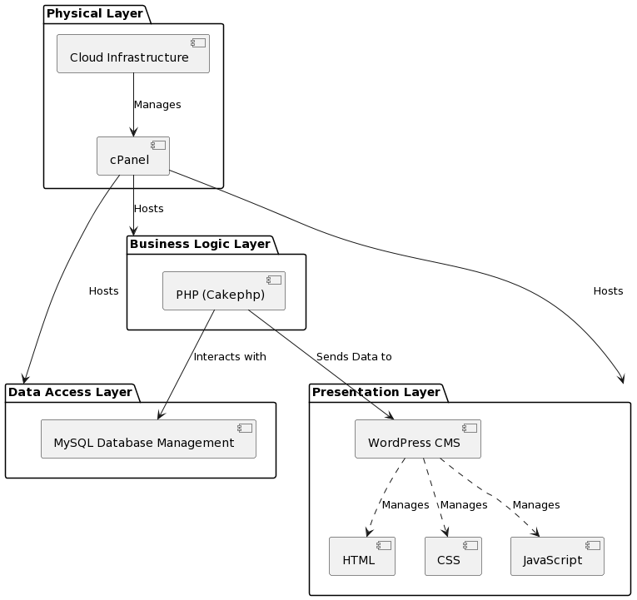

Figure 6. Architectural Design

Figure 6, illustrates the architectural design of Cleveland State University's Human Resource Management Panel and following are the description of each layer:

Presentation Layer: This layer will be implemented using HTML, CSS, and JavaScript. WordPress will serve as the Content Management System (CMS), allowing easy content updates and ensuring a cohesive user interface. The Presentation Layer is intricately designed using a combination of HTML coding, Multiple CSS styling, and JavaScript. These technologies synergize to deliver a dynamic, responsive, and visually appealing interface for users. To further enhance content management and ensure a consistent user experience, WordPress has been adopted as the preferred Content Management System (CMS). Its user-friendly dashboard and extensive customization options empower administrators to effortlessly update content and maintain the visual integrity of the platform.

Business Logic Layer: This layer takes care of the operational logic and rules. It will be primarily coded in PHP (Cakephp), which will interact with both the Presentation and Data Access layers. Through this layer, the application can dynamically respond to user inputs, process requests, and relay information between the front-end and the back-end with precision and efficiency. This will also be responsible to connect presentation layer and Data Access layer.

Data Access Layer: MySQL is chosen as the database management system to handle data storage, retrieval, and manipulation. This layer serves as an interface between the Business Logic Layer and the database. Acting as a pivotal interface, the Data Access Layer seamlessly bridges the gap between the Business Logic Layer and the database. This ensures a streamlined flow of information, allowing the application's logic to interact with stored data without direct exposure to underlying database complexities. Furthermore, this layer provides a level of abstraction, ensuring that any changes or optimizations to the database can be carried out without impacting the business logic or presentation layers, thus fostering system maintainability and flexibility.

Physical Layer: The application will be hosted on a cloud infrastructure, leveraging cPanel for web hosting management. This cloud-based approach guarantees enhanced scalability, allowing the system to handle increased loads or expanded functionalities without significant infrastructure changes. Furthermore, the cloud infrastructure provides robustness, ensuring high availability and minimal downtime. By opting to rent space on this cloud infrastructure, Cleveland State University can benefit from state-of-the-art physical and cyber security measures. These measures not only protect the data from unauthorized access but also safeguard against potential physical threats like natural disasters, ensuring that the university's Human Resource Management Panel remains operational and the data remains intact.

## **4.3. Technology, software, and hardware used**

The successful implementation of the Human Resource Management Panel (HRM) project at Cleveland State University relies on a robust combination of hardware and software resources. The chosen technological framework centers around the integration of PHP, JavaScript, WordPress, and MySQL. On the front-end, JavaScript is employed to craft a responsive and user-friendly interface, ensuring an optimal user experience for HR professionals and employees. The back-end leverages PHP for server-side scripting and MySQL as the relational database management system, providing a secure and scalable foundation for data storage and retrieval. The hardware requirements include servers capable of hosting the web application efficiently, ensuring reliable performance and responsiveness. Additionally, the software infrastructure encompasses the utilization of WordPress, a versatile content management system, to facilitate content creation, publication, and management. These combined hardware and software resources form a cohesive and powerful ecosystem, laying the groundwork for the development of an advanced HRM solution tailored to meet the specific needs of Cleveland State University.

## **4.4. Rationale for your architectural style and model**

The chosen architectural style and model for the HRM project reflect a deliberate approach aimed at achieving modularity, scalability, and maintainability. The adoption of a three-tier architecture, comprising the Presentation Layer, Logical Layer, Data Access Layer, and Physical Layer, is driven by several key considerations.

* Modularity:
* Rationale: The modular architecture facilitates the separation of concerns, allowing for the independent development and maintenance of different components. This enhances code reusability, ease of debugging, and the ability to update or extend specific functionalities without affecting the entire system.
* Implications: Changes or enhancements in one layer, such as the Presentation Layer, can be implemented without disrupting the underlying logic or data access components, fostering flexibility and agility in development.
* Scalability
* Rationale: The three-tier architecture inherently supports scalability by distributing the application across layers. This design accommodates growth in user base and data volume by allowing each layer to scale independently based on demand.
* Implications: As user and data requirements evolve, the HRM Panel can scale horizontally or vertically in specific layers, optimizing performance and resource utilization without necessitating a complete system overhaul.
* Maintainability:
* Rationale: The separation of concerns in the three-tier architecture enhances maintainability by providing a clear and organized structure. This ensures that updates, bug fixes, or enhancements can be implemented with minimal risk of unintended consequences.
* Implications: Maintenance tasks become more straightforward, as developers can focus on specific layers without the need to navigate complex interdependencies. This approach streamlines the development life cycle and facilitates long-term sustainability.
* Adaptability to Change:
* Rationale: The three-tier architecture aligns with an iterative and incremental development approach, facilitating adaptability to changing requirements. Each layer can be modified or extended without affecting the overall system functionality.
* Implications: The HRM Panel can readily evolve in response to new features, technological advancements, or shifts in user needs, ensuring that the system remains current and relevant over time.

# **5. Design**

## **5.1. User Interface design**

The user interface design of the Human Resource Management (HRM) panel software for Cleveland State University can play a crucial role in providing a seamless and user-friendly experience for both HR professionals and employees. Following segments delineate various segments of the HRM website.

### **5.1.1 Description of the user interface**

Followings are the vital segments of the HRM software for Cleveland State University.

* Home: The “Home” tab serves as the landing page for the HRM software. It includes an overview of the HR department's role, updates, and quick links to key features.

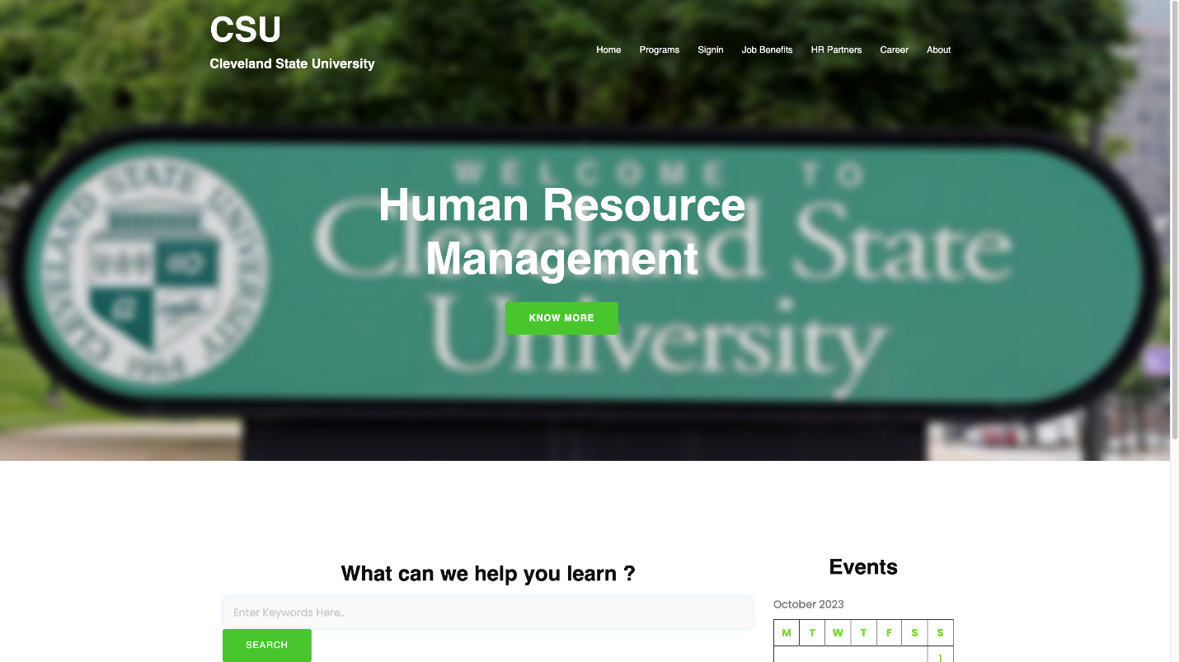

Figure 7. Home Page

* Programs: The “programs” tab contains development programs for the employees. It includes professional development, leadership training and team development tabs. Each segment redirects itself to its respective portal for the relevant and on-demand training for the employees.



Figure 8. Program Tab

The professional development tab offers various modules to help exploring various professional training options. Each segment contains the details of the training program modules and its estimated duration. Employees can directly enroll from this tab and can get started with the training right away.

Figure 9. Professional Development Page

* Job Benefits: The "Job Benefits" tab is where employees can access information regarding their benefits, such as health insurance, retirement plans, and any related documents. This section could also provide tools for benefits management.
* Career: This tab is dedicated to career and job opportunities offered by Cleveland State University. It is a one-stop drop point for the institute where all jobs are posted where users can browse all the job listing. Users can also find details on various job openings both on-campus and off-campus jobs (managed by university authorities).
* Login: The "Login" tab is the gateway for authorized users to access their HR accounts. This is where employees and HR professionals enter their credentials to access the system.
* Event Calendar: The "Event Calendar" segment features a calendar view of upcoming HR-related events, such as workshops, training sessions, or benefits enrollment periods. Users can register for events here.

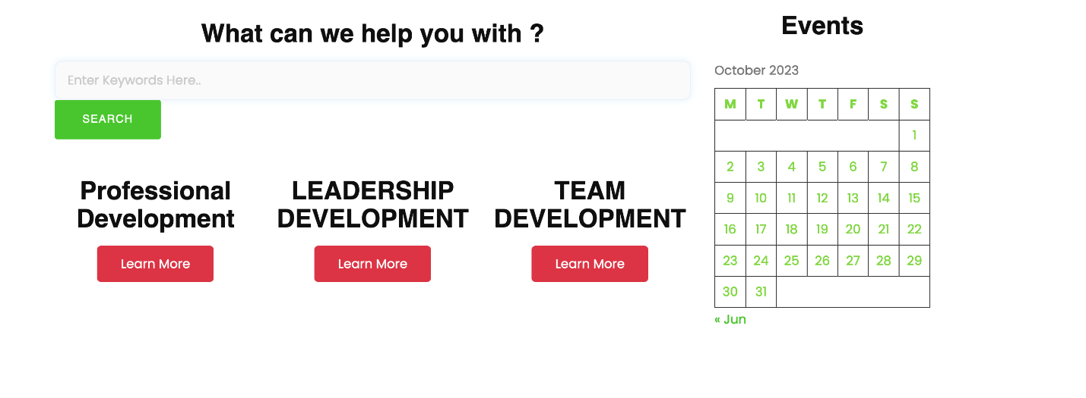

Figure 10. Event Calendar Feature

* Search Form: The “Search Form” aids users to look for different segments and contents within the website. It offers easier navigation without needing to search for required ant segment that is relevant to the user.
* Contact Us: "Contact Us" is a tab that provides contact information for the HR department. Users can find phone numbers, email addresses, and physical addresses for inquiries or appointments.
* HR Partners: The "HR Partners" tab is for HR professionals within the university. It provides access to tools and resources specifically designed for HR staff, such as reports, administrative functions, and collaboration tools.

### **5.1.2 Interface design rules**

In terms of design, the interface would follow best practices for user experience and accessibility:

* Navigation: A clean and intuitive menu at the top of the interface, likely a horizontal navigation bar, with drop-down menus for sub-items under some tabs.
* Branding: Consistent use of Cleveland State University branding, colors, and logos to maintain a sense of identity.
* Search functionality: A search bar to help users quickly find specific information or documents.
* Responsive design: Ensure that the interface is responsive, so it works well on various devices (desktop, tablet, mobile).
* Accessibility: Comply with accessibility standards (e.g., WCAG) to ensure that the interface is usable by all, including those with disabilities.
* Security: Robust security features to protect sensitive HR data and ensure user privacy.
* Feedback mechanism: Include a way for users to provide feedback or report issues to continuously improve the software.

The overall design is intended to prioritize user-friendliness and efficiency, making it easy for employees and HR professionals to navigate the HRM software and access the information and tools they need.

## **5.2. Components design**

A description of major software components contained within the architecture is presented as illustrated in Figure 1 for Cleveland State University's Human Resource Management Panel.

#### **5.2.1 Presentation Layer**

The Presentation Layer is the primary interface users interact with. It determines how content is displayed and managed.

#### **5.2.1.1 Interface description**

Input: User interactions, content updates via WordPress CMS.

Output: Dynamic, responsive, and visually appealing interface.

Technologies: HTML, CSS, JavaScript, WordPress CMS.

Exceptions: Any discrepancies in content display or interactive elements malfunctioning.

#### **5.2.1.2 Class diagrams for Presentation Layer (static model)**

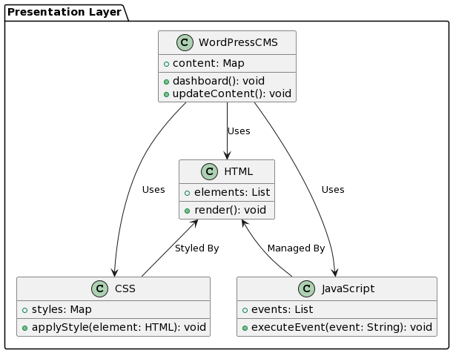

Figure 11. Class diagrams for Presentation Layer

### **5.2.2 Business Logic Layer**

This layer manages the operational logic and rules of the application, ensuring seamless integration with both the Presentation and Data Access layers.

#### **5.2.2.1 Interface description**

Input: User requests and data from Presentation Layer.

Output: Processed information relayed to Presentation or Data Access Layer.

Technologies: PHP (Cakephp).

Exceptions: Errors in data processing, logic discrepancies.

#### **5.2.2.2 Class diagrams for Business Logic Layer (static model)**

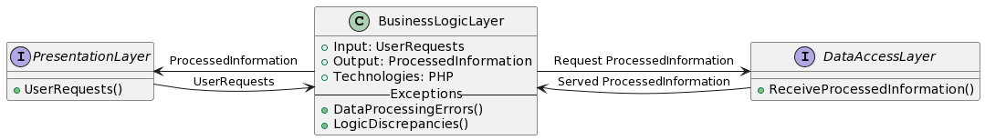

Figure 12. Class diagrams for Business Logic Layer

### **5.2.3 Data Access Layer**

Responsible for data storage, retrieval, and manipulation. Serves as a bridge between the Business Logic Layer and the database.

##### **5.2.3.1 Interface description**

Input: Data requests from the Business Logic Layer.

Output: Stored or retrieved data.

Technologies: MySQL.

Exceptions: Database connectivity issues, data retrieval or storage errors.

#### **5.2.3.2 Class diagrams for Data Access Layer (static model)**

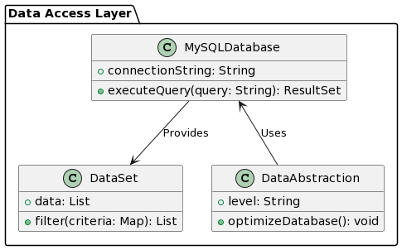

Figure 13. Class diagrams for Data Access Layer

### **5.2.4 Physical Layer**

This layer represents the foundational hardware and infrastructure of the system.

#### **5.2.4.1 Interface description**

Input: All system operations, including requests from other layers.

Output: Managed cloud resources ensuring high availability.

Technologies: Cloud Infrastructure, cPanel.

Exceptions: Downtime, infrastructure malfunctions, unauthorized access attempts.

#### **5.2.4.2 Class Diagram for Physical Layer (static model)**

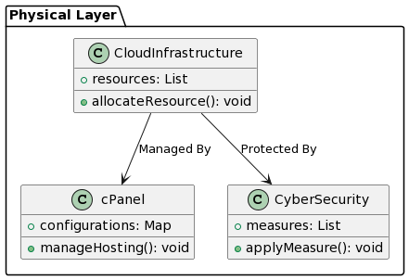

Figure 14. Class Diagram for Physical Layer

## **5.3. Database design**

The HRM software will manage and manipulate several data objects, essential for HR processes. These objects are described in detail below:

* Employee Profile: This data object includes attributes such as Employee ID, First Name, Last Name, Contact Details, Position, Date of Hire, etc.
* Professional Development: Contains attributes like Development Program ID, Employee ID, Program Name, Duration, Date of Completion, and Feedback.
* Leadership Training: Attributes include Training ID, Employee ID, Training Type, Duration, Date, and Outcomes.
* Compensation: Consists of attributes like Employee ID, Base Salary, Bonus, Allowances, and Total Compensation.
* Benefits: Includes Benefits ID, Employee ID, Type of Benefit (medical, dental, retirement, etc.), and Enrollment Status.
* Job Application: Contains attributes like Application ID, Position Applied For, Resume Submission Date, Status, and Interview Date.
* Events: Attributes include Event ID, Description, Date, Location, and Participants.

### **5.3.1 Relationships**

Relationships without an actual Entity-Relationship Diagram (ERD) visualization, the relationships are described in natural language format in the following:

* Each Employee can enroll in multiple Professional Development programs, and each program enrollment relates to multiple employees.
* Each Employee can undergo multiple Leadership Training sessions, and each training session relates to multiple employees.
* Each Employee can be part of multiple Team Development initiatives, and each team development relates to multiple employees.
* Each Employee has one About Page entry, which provides details related to them.
* An Employee can have multiple Benefits, indicating a one-to-many relationship.
* An Employee may have one Compensation record, indicating the relationship as one-to-one.
* Each Employee can be associated with multiple HR Partners, and each HR Partner entry relates to multiple employees.
* Each Employee can be part of multiple Learning and Organizational Development initiatives, and each entry relates to multiple employees.
* Each Employee can have multiple Career entries or job positions.
* Each Employee can be associated with multiple Event Calendars, indicating their participation or interest in various events.
* 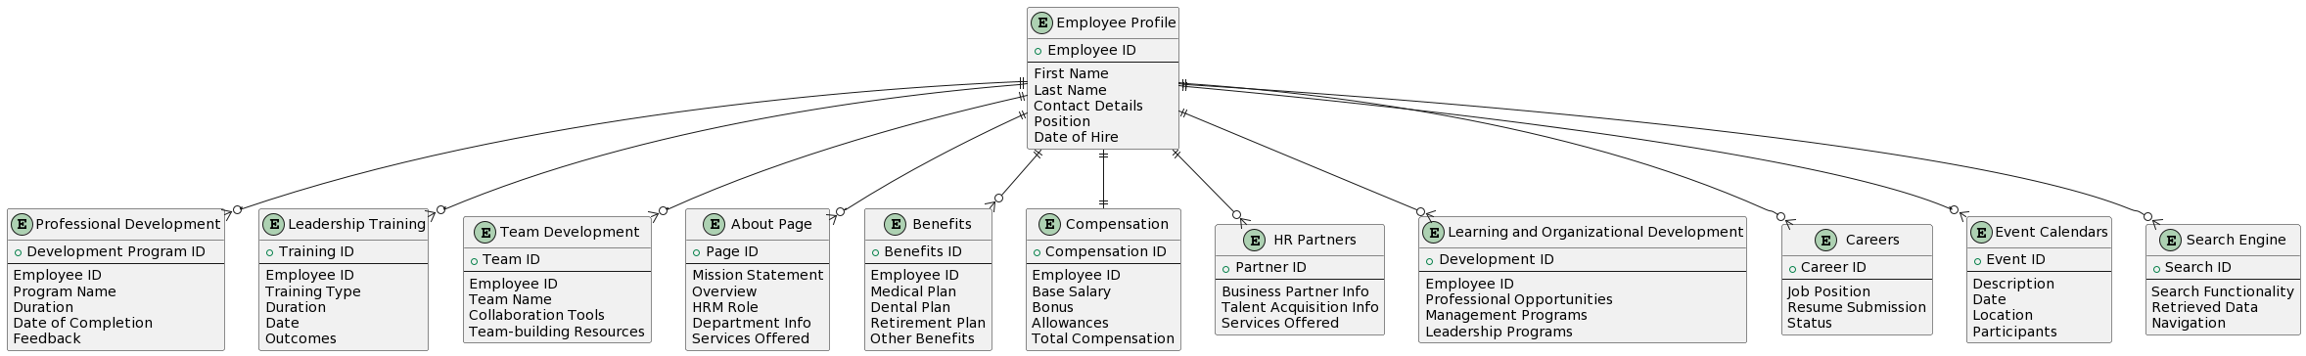Each Employee can have multiple Search Engine functionalities associated with them.

Figure 15. Database Design Model

### **5.3.2 Complete Data Model**

Following is the Entity-Relationship Diagram (ERD) visualization:

### **5.3.3 Data Dictionary**

This data dictionary provides a detailed overview of each entity and their attributes in the system, along with a brief description and the expected data type for each attribute.

Table 2. Data Dictionary

|  |  |  |  |
| --- | --- | --- | --- |
| Entity | Attribute | Description | Data Type |
| Employee Profile | Employee ID | Unique identifier for each employee | Number |
|  | First Name | Employee's first name | String |
|  | Last Name | Employee's last name | String |
|  | Contact Details | Employee's contact information | String |
|  | Position | Job position of the employee | String |
|  | Date of Hire | The date when the employee was hired | Date |
| Professional Development | Development Program ID | Unique identifier for each development program | Number |
|  | Employee ID | Identifier linking to the Employee Profile | Number |
|  | Program Name | Name of the development program | String |
|  | Duration | Duration of the program | String |
|  | Date of Completion | Date when the program was completed | Date |
|  | Feedback | Feedback provided by the employee for the program | String |
| Leadership Training | Training ID | Unique identifier for each leadership training | Number |
|  | Employee ID | Identifier linking to the Employee Profile | Number |
|  | Training Type | Type of leadership training | String |
|  | Duration | Duration of the training | String |
|  | Date | Date of the training | Date |
|  | Outcomes | Results or outcomes of the training | String |
| Compensation | Employee ID | Identifier linking to the Employee Profile | Number |
|  | Base Salary | Basic salary of the employee | Number |
|  | Bonus | Bonus amount | Number |
|  | Allowances | Other allowances given to the employee | Number |
|  | Total Compensation | Sum of base salary, bonus, and allowances | Number |
| Benefits | Benefits ID | Unique identifier for each benefit | Number |
|  | Employee ID | Identifier linking to the Employee Profile | Number |
|  | Type of Benefit | Type or category of the benefit | String |
|  | Enrollment Status | Status indicating if the benefit is enrolled or not | String |
| Job Application | Application ID | Unique identifier for each job application | Number |
|  | Position Applied For | Position for which the application was made | String |
|  | Resume Submission Date | Date when the resume was submitted | Date |
|  | Status | Status of the job application | String |
|  | Interview Date | Date of the interview, if scheduled | Date |
| Events | Event ID | Unique identifier for each event | Number |
|  | Description | Description or details about the event | String |
|  | Date | Date of the event | Date |
|  | Location | Venue or location of the event | String |
|  | Participants | Number of participants or attendees for the event | Number |

## **5.4. Rationale for your detailed design models**

The detailed design models for the HRM panel are grounded in the overarching architectural principles of modularity, scalability, and maintainability. The adoption of a three-tier architecture further solidifies these principles, ensuring a cohesive and efficient system design.

* Modularity: The detailed design models incorporate a modular approach, breaking down the system into distinct layers — Presentation, Logical, and Data Access. This modularity enhances flexibility, allowing for the independent development, testing, and maintenance of each layer. Changes to one layer have minimal impact on others, facilitating easier updates and modifications.
* Scalability: The three-tier architecture is chosen for its inherent scalability. The Presentation Layer focuses on user interfaces, the Logical Layer handles application logic, and the Data Access Layer manages database interactions. This division enables horizontal scaling by adding resources to individual layers as needed, accommodating growing user bases and data volumes seamlessly.
* Maintainability: The modular and layered design contributes to the system's maintainability. Updates or enhancements can be localized to specific layers, reducing the risk of unintended consequences. The separation of concerns ensures that maintenance efforts are targeted and efficient, promoting long-term sustainability.
* Three-Tier Architecture: Presentation Layer: This layer handles user interfaces, ensuring a responsive and intuitive experience for HR professionals and employees. It accommodates changes in user interface requirements without impacting the underlying logic or data access.
* Logical Layer: Application logic resides in this layer, overseeing the processing of data and business rules. It promotes the centralization of core functionalities, making it easier to manage, optimize, and update the system's logic.
* Data Access Layer: Responsible for managing interactions with the database, this layer ensures efficient data retrieval and storage. The separation of data-related operations enhances database performance and facilitates changes to the underlying database structure.
* Physical Layer: The Physical Layer, not only part of the three-tier architecture but also a critical component, refers to the hardware and infrastructure supporting the entire system. The design ensures compatibility with existing university infrastructure and provides a foundation for future hardware upgrades or changes.

In summary, the detailed design models align with the system's architectural choices, emphasizing modularity for flexibility, scalability for accommodating growth, and maintainability for efficient long-term management. The three-tier architecture, with its distinct layers, enhances the system's ability to evolve, adapt, and deliver optimal performance for Cleveland State University's human resources management needs.

## **5.5. Traceability from requirements to detailed design models**

The detailed design models are intricately linked to the specified requirements, ensuring a seamless transition from conceptualization to implementation for each major function identified in Section 4.1. Each requirement is traceable to specific design considerations as follows:

* Professional Development Interface:
* User-Friendly Interface: Reflected in the detailed design through responsive web design principles, ensuring accessibility on various phone screens.
* Integration with Event Calendars: Implemented in the Presentation Layer for seamless integration with event calendars, promoting and tracking training sessions.
* Leadership Training Module:
* Access to Leadership Resources: Addressed in the Logical Layer, detailing the structure for accessing and managing comprehensive leadership training resources.
* Interactive Modules: Incorporated in the Presentation Layer, focusing on the design of interactive modules for enhancing leadership skills.
* Team Development Tools:
* Collaboration Tools: Defined in the Logical Layer for the introduction of collaboration tools dedicated to team functions.
* Integration with HR Processes: Implemented in the Data Access Layer, ensuring close integration with HR processes for effective team development initiatives.
* About Page Content:
* Mission Statement Display: Encompassed in the Presentation Layer, detailing the layout for displaying the mission statement and HRM's role.
* Information Detailing: Outlined in the Logical Layer, specifying the design for presenting exhaustive information about HR departments and their functions.
* Comprehensive Benefits Information:
* Access to Employee Benefits: Addressed in the Logical Layer, defining the structure for allowing unbridled access to detailed benefits information.
* Online Enrollment and Management: Implemented in the Presentation Layer, ensuring an intuitive design for online enrollment and benefits program management.
* Compensation Data Access:
* Access to Compensation Data: Incorporated in the Data Access Layer, specifying the database interactions for accessing extensive compensation data.
* Support for Job Design: Addressed in the Logical Layer, outlining functionalities supporting job design during reorganization and restructuring phases.
* HR Partners Overview:
* Display of HR Partners Information: Encompassed in the Presentation Layer, defining the layout for displaying information about HR Business and Talent Acquisition Partners.
* Service Offerings Integration:* Implemented in the Logical Layer, detailing the integration with services such as change management and organizational design.
* Learning & Organizational Development Access:
* Access to Programs: Outlined in the Presentation Layer, specifying the design for granting access to professional development and leadership programs.
* Integration with Event Calendars: Incorporated in the Logical Layer, ensuring effective integration for scheduling training sessions.
* Careers Portal:
* Job Posting and Application Mechanisms: Addressed in the Presentation Layer, defining the mechanisms for job posting and application.
* Integration with HR Processes: Implemented in the Data Access Layer, ensuring seamless integration with HR processes for streamlined hiring.
* Event Calendars Feature:
* Comprehensive Event Calendars: Encompassed in the Presentation Layer, detailing the design for implementing event calendars tailored for HR-centric events.
* Registration and Attendance Tracking: Addressed in the Logical Layer, specifying functionalities for event registration and attendance tracking.
* Search Engine Utility:
* Robust Search Engine: Incorporated in the Logical Layer, outlining the design for a robust search engine to swiftly locate HR-related information.
* User-Friendly Navigation: Addressed in the Presentation Layer, ensuring the search engine aids in easy navigation and swift content retrieval.

# **6. Test Management**

## **6.1. A complete list of system test cases**

This section enumerates a complete list of test cases based on different scenarios for the HRM panel structured with test ID, test input, expected output, and description (with some of the testing screenshots):

Test case scenarios: Page functionality

|  |  |
| --- | --- |
| ID | TC001 |
| Test Input | Click on the "Home” tab |
| Expected Output | Redirect to the home page of the HRM website |
| Description | Ensure that clicking on the "Home" tab properly lands on the home page |

|  |  |
| --- | --- |
| ID | TC002 |
| Test Input | Click on the "Sign in” tab |
| Expected Output | Redirect to the Sign in page of the HRM website |
| Description | Verify that clicking on the "Sign in" tab properly redirects to the Sign in page. |

|  |  |
| --- | --- |
| ID | TC003 |
| Test Input | Click on the "Career” tab |
| Expected Output | Redirect to the career portal |
| Description | Ensure that clicking on the "Career" tab properly redirects to the career portal |

|  |  |
| --- | --- |
| ID | TC004 |
| Test Input | Click on the "Professional Development" tab |
| Expected Output | Redirect to the professional development portal with a list of training modules |
| Description | Verify that clicking on the "Professional Development" tab redirects to the appropriate portal with a list of available training modules. |

|  |  |
| --- | --- |
| ID | TC005 |
| Test Input | Click on the "Job Benefits" tab |
| Expected Output | Redirect to the job benefits page relevant to the user |
| Description | Verify that clicking on the "Job Benefits" tab redirects to the appropriate portal with a list of available plans |

|  |  |
| --- | --- |
| ID | TC006 |
| Test Input | Click on the "About" tab |
| Expected Output | Redirect to the about page |
| Description | Verify that clicking on the "About" tab redirects to the appropriate page with institution details, contact information etc. |

Test case scenarios: User login and registration

|  |  |
| --- | --- |
| ID | TC007 |
| Test Input | Valid user credentials (username and password) |
| Expected Output | Successful login, redirect to the user dashboard |
| Description | Verify that users can log in successfully with valid credentials. |

|  |  |
| --- | --- |
| ID | TC008 |
| Test Input | Invalid user credentials (incorrect password) |
| Expected Output | Display error message "Invalid credentials" |
| Description | Ensure that the system does not allow login with incorrect passwords. |

|  |  |
| --- | --- |
| ID | TC009 |
| Test Input | Blank username and password fields |
| Expected Output | Display error messages for missing credentials |
| Description | Verify that the system prompts users to enter both username and password. |

|  |  |
| --- | --- |
| ID | TC010 |
| Test Input | New user registration form with valid information |
| Expected Output | Successful login, redirect to the user dashboard |
| Description | Verify that users can log in successfully with valid credentials. |

Test case scenarios: Employee enrollment

|  |  |
| --- | --- |
| ID | TC011 |
| Test Input | Employee details for a new hire |
| Expected Output | Employee record added successfully |
| Description | Ensure HR administrators can add new employees with correct information. |

|  |  |
| --- | --- |
| ID | TC012 |
| Test Input | Attempt to add an employee with duplicate information |
| Expected Output | Display error message "Employee already exists" |
| Description | Check that the system prevents the addition of duplicate employee records. |

Test case scenarios: Leave request and approval process

|  |  |
| --- | --- |
| ID | TC013 |
| Test Input | Leave request with valid details |
| Expected Output | Leave request submitted successfully, pending approval |
| Description | Verify that employees can request leaves and the system processes it correctly. |

|  |  |
| --- | --- |
| ID | TC014 |
| Test Input | HR administrator approving a leave request |
| Expected Output | Leave request approved, reflected in the employee's leave balance |
| Description | Ensure HR administrators can approve leave requests, and the system updates leave balances accordingly. |

Test case scenarios: Development program modules and enrollment

|  |  |
| --- | --- |
| ID | TC015 |
| Test Input | Enroll in a specific professional development module |
| Expected Output | Successful enrollment, user redirected to the module details |
| Description | Ensure that users can successfully enroll in a professional development module from the "Professional Development" tab. |

|  |  |
| --- | --- |
| ID | TC016 |
| Test Input | Explore modules within the "Team Development" tab |
| Expected Output | View a list of team development modules with their details |
| Description | Ensure that users can explore and view details of various team development modules. |

3.6 Test case scenarios: Employee details and payroll

|  |  |
| --- | --- |
| ID | TC017 |
| Test Input | Performance goals set for an employee |
| Expected Output | Goals saved successfully for the employee |
| Description | Confirm that performance goals can be set for employees. |

|  |  |
| --- | --- |
| ID | TC018 |
| Test Input | Attempt to access confidential employee information without proper permissions |
| Expected Output | Access denied, display error message |
| Description | Verify that unauthorized users cannot access sensitive HR information. |

|  |  |
| --- | --- |
| ID | TC019 |
| Test Input | Generate a payroll report |
| Expected Output | Accurate payroll report with salary details |
| Description | Verify that the system generates accurate payroll reports. |

3.7 Test case scenarios: Job benefits and plans

|  |  |
| --- | --- |
| ID | TC020 |
| Test Input | Access the "Health Insurance" section |
| Expected Output | View information about health insurance benefits and related documents |
| Description | Confirm that users can access information about health insurance benefits and related documents from the "Job Benefits" tab. |
| ID | **TC021** |
| Test Input | Manage retirement plans |
| Expected Output | Access tools for managing retirement plans |
| Description | Verify that users can access tools for managing retirement plans from the "Job Benefits" tab. |

|  |  |
| --- | --- |
| ID | TC022 |
| Test Input | Upload a document related to benefits |
| Expected Output | Document uploaded successfully and visible in the "Job Benefits" tab |
| Description | Ensure that users can upload documents related to benefits, and the uploaded document is visible in the corresponding section. |

3.8 Test case scenarios: Career and job listings

|  |  |
| --- | --- |
| ID | TC023 |
| Test Input | View on-campus job listings |
| Expected Output | Display a list of on-campus job opportunities |
| Description | Verify that clicking on the "On-Campus Jobs" section in the "Career" tab displays a list of available on-campus job opportunities. |

|  |  |
| --- | --- |
| ID | TC024 |
| Test Input | Search for off-campus job openings |
| Expected Output | Display a list of off-campus job opportunities |
| Description | Confirm that users can search for and view details of off-campus job openings from the "Career" tab. |

|  |  |
| --- | --- |
| ID | TC025 |
| Test Input | Apply for a specific job listing |
| Expected Output | Successful submission of the job application |
| Description | Ensure that users can successfully apply for a job listing through the "Career" tab. |

3.9 Test case scenarios: Compatibility, performance and Neilo AB Testing Functionality

|  |  |
| --- | --- |
| ID | TC026 |
| Test Input | Test the website on a mobile device |
| Expected Output | All features are accessible and responsive on the mobile device |
| Description | Check the mobile responsiveness of the HRM website. |

|  |  |
| --- | --- |
| ID | TC027 |
| Test Input | Access the HRM website using latest versions of popular browsers (Such as Google Chrome, Mozilla Firefox, Edge, Safari etc.) |
| Expected Output | All features are accessible and display correctly |
| Description | Ensure compatibility with the latest version of the popular browsers |

|  |  |
| --- | --- |
| ID | TC028 |
| Test Input | Access the HRM website on a tablet device |
| Expected Output | All features are accessible and responsive on the tablet device |
| Description | Test compatibility on tablet devices to ensure a seamless user experience. |

|  |  |
| --- | --- |
| ID | TC029 |
| Test Input | Access the HRM website on different screen resolutions (e.g., 1920x1080, 1366x768) |
| Expected Output | All features are accessible and adapt to various screen resolutions |
| Description | Ensure compatibility with different screen resolutions commonly used by users. |

|  |  |
| --- | --- |
| ID | TC030 |
| Test Input | Enable/disable browser cookies and access the HRM website |
| Expected Output | All features are accessible, and the website functions correctly with or without cookies |
| Description | Test compatibility with different cookie settings to ensure functionality in various user configurations. |

|  |  |
| --- | --- |
| ID | TC031 |
| Test Input | Perform a website speed test using Site Speed Test-Speed Guard. |
| Expected Output | Perform a website speed test using Site Speed Test-Speed Guard. |
| Description | Verify that Site Speed Test-Speed Guard can accurately measure and report website speed. |

|  |  |
| --- | --- |
| ID | TC032 |
| Test Input | Monitor and analyze the results of an ongoing A/B test using Nelio AB Testing. |
| Expected Output | All features are accessible and adapt to various screen resolutions Detailed data on user interactions and conversion rates. |
| Description | Verify that Nelio AB Testing provides accurate and informative results for A/B tests. |

3.10 Test case scenario: Backup Functionality

|  |  |
| --- | --- |
| ID | TC033 |
| Test Input | Initiate a backup of the website using Backuply. |
| Expected Output | A successful backup of the website data. |
| Description | Verify that Backuply can perform a backup of the website's data without errors. |

Test case scenarios: Bulletproof Security Functionality

|  |  |
| --- | --- |
| ID | TC034 |
| Test Input | Restore a backup from a previous backup using Backuply. |
| Expected Output | The website is restored to its previous state without issues. |
| Description | Ensure that Bulletproof Security can properly configure security settings for the website. |

|  |  |
| --- | --- |
| ID | TC035 |
| Test Input | Initiate a malware scan using Bulletproof Security |
| Expected Output | The scan identifies and quarantines any malware found. |
| Description | Verify that Bulletproof Security can effectively scan and remove malware from the website. |

Test Case scenario: Database Cleanup

|  |  |
| --- | --- |
| ID | TC036 |
| Test Input | Run a database cleanup operation using Advanced Database Cleaner. |
| Expected Output | Unnecessary data and files are removed, and the database is optimized. |
| Description | Verify that Advanced Database Cleaner can clean up the database and improve its performance. |

In conclusion, the comprehensive test cases designed for the HRM website cover a spectrum of critical functionalities, ensuring the robustness and reliability of the system. From user authentication to performance, database integrity, and compatibility across browsers and devices, the test suite aims to validate a seamless user experience. By meticulously addressing scenarios such as leave management, employee information, and security features, these test cases contribute to the overall quality assurance of the HRM panel. Employing these test scenarios will not only detect potential issues but also fortify the website's functionality, assuring users of a secure, efficient, and user-friendly HRM platform while ensuring seamless operations for Cleveland State University.

## **6.2. Traceability of test cases to use cases**

* Page functionality:
* TC001: Home tab -> Use Case 1 (Modify Employee)
* TC002: Sign in tab -> Use Case 5 (Modify Account)

TC003: Career tab -> Use Case 13 (View Jobs)

* TC004: Professional Development tab -> Use Case 14 (View Development Program)
* TC005: Job Benefits tab -> Use Case 18 (View Benefits and Compensation)
* TC006: About tab -> N/A (This seems to be a general navigation test)
* User login and registration:
* TC007: Valid user credentials -> N/A (This is a general login test)
* TC008: Invalid user credentials -> N/A (This is a general login test)
* TC009: Blank username and password fields -> N/A (This is a general login test)
* TC010: New user registration -> N/A (This is a general registration test)
* Employee enrollment:
* TC011: Employee details for a new hire -> Use Case 2 (Enroll Employee)
* TC012: Attempt to add an employee with duplicate information -> N/A (This seems to be a data integrity test)
* Leave request and approval process:
* TC013: Leave request with valid details -> N/A (This is a general leave request test)
* TC014: HR administrator approving a leave request -> N/A (This is a general leave approval test)
* Development program modules and enrollment:
* TC015: Enroll in a specific professional development module -> Use Case 2 (Enroll Employee)
* TC016: Explore modules within the "Team Development" tab -> Use Case 14 (View Development Program)
* Employee details and payroll:
* TC017: Performance goals set for an employee -> Use Case 1 (Modify Employee)
* TC018: Attempt to access confidential employee information without proper permissions -> N/A (This is a security test)
* TC019: Generate a payroll report -> N/A (This is a general payroll test)
* Job benefits and plans:
* TC020: Access the "Health Insurance" section -> Use Case 18 (View Benefits and Compensation)
* TC021: Manage retirement plans -> Use Case 18 (View Benefits and Compensation)
* TC022: Upload a document related to benefits -> Use Case 18 (View Benefits and Compensation)
* Career and job listings:
* TC023: View on-campus job listings -> Use Case 13 (View Jobs)
* TC024: Search for off-campus job openings -> Use Case 13 (View Jobs)
* TC025: Apply for a specific job listing -> Use Case 13 (View Jobs)
* Compatibility, performance, and Neilo AB Testing Functionality:
* TC026: Test the website on a mobile device -> N/A (This is a general compatibility test)
* TC027: Access the HRM website using the latest versions of popular browsers -> N/A (This is a general compatibility test)
* TC028: Access the HRM website on a tablet device -> N/A (This is a general compatibility test)
* TC029: Access the HRM website on different screen resolutions -> N/A (This is a general compatibility test)
* TC030: Enable/disable browser cookies and access the HRM website -> N/A (This is a general compatibility test)
* TC031: Perform a website speed test -> N/A (This is a general performance test)
* TC032: Monitor and analyze the results of an ongoing A/B test -> N/A (This is a general A/B testing functionality test)
* Backup Functionality:
* TC033: Initiate a backup of the website using Backuply -> N/A (This is a general backup test)
* Bulletproof Security Functionality:
* TC034: Restore a backup from a previous backup using Backuply -> N/A (This is a general security test)
* TC034: Initiate a malware scan using Bulletproof Security -> N/A (This is a general security test)
* Database Cleanup:
* TC035: Run a database cleanup operation using Advanced Database Cleaner -> N/A (This is a general database cleanup test)
* Please note that some tests are marked as "N/A" because they seem to be more general tests or related to system configurations rather than specific functionalities described in the provided use cases. Adjustments can be made based on the specific functionalities you want to test.

## **6.3. Techniques used for test case generation**

* Equivalence Partitioning:
* Description:
* Equivalence Partitioning is a testing technique that involves dividing the input space into classes or partitions based on the assumption that if a system behaves correctly for one input in a partition, it should behave correctly for all inputs in that partition.
* Test cases are then designed to represent each partition, minimizing redundancy and ensuring comprehensive coverage.
* Application:
* In the context of the HRM system, Equivalence Partitioning can be applied to various scenarios. For example, when testing user authentication, input partitions may include valid usernames, invalid usernames, valid passwords, and invalid passwords. Test cases would then be created to cover each partition.
* Example:
* If a system allows employees to submit leave requests, Equivalence Partitioning would involve testing scenarios for valid leave durations, invalid durations, and leave requests on weekends. Test cases would be designed to represent each partition, ensuring the system's behavior is thoroughly tested.
* Boundary Value Analysis:
* Description:
* Boundary Value Analysis is a testing technique that focuses on testing values at the edges or boundaries of input domains. The objective is to uncover errors that may exist at these critical points and to ensure the system behaves as expected near the boundaries of valid input ranges.
* Application:
* In the HRM system, Boundary Value Analysis can be applied to scenarios where inputs have specific valid ranges. For instance, when specifying the number of hours for a training session, test cases would be designed to cover values at the lower and upper boundaries of the valid range.
* Example:
* Consider a situation where the HR system accepts a range of working hours per day for an employee. Boundary Value Analysis would involve testing the system's response to the minimum and maximum allowable working hours to ensure it behaves correctly at these critical points.
* Combined Use:
* Example Scenario:
* When testing the functionality related to modifying an employee's profile, Equivalence Partitioning can be used to identify different classes of inputs (e.g., updating contact details, educational qualifications, or work experience). Within each class, Boundary Value Analysis can be applied to test the system's behavior at the edges of permissible data, such as the minimum and maximum lengths of a phone number or the maximum characters allowed for an address.
* Advantages:
* Efficiency: Equivalence Partitioning reduces redundancy by grouping similar inputs, and Boundary Value Analysis enhances efficiency by focusing on critical points, optimizing the overall testing process.
* Coverage: The combination of these techniques ensures a comprehensive coverage of various input scenarios, increasing the likelihood of detecting potential issues.

## **6.4. Test results and assessments:**

In this section, we present the results of the most important test cases as follows:

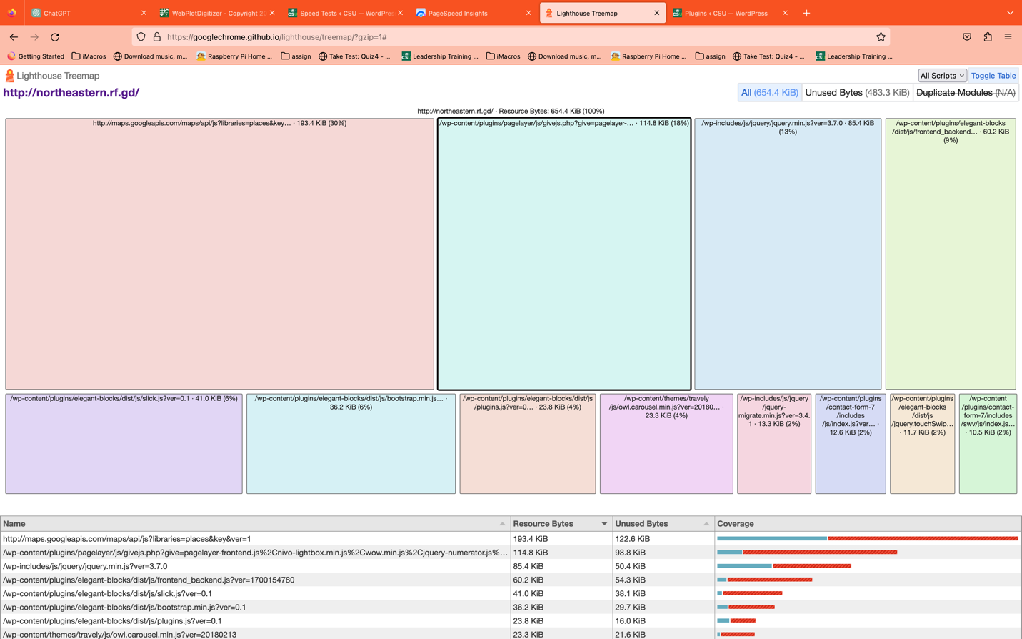

Figure 16. TC030 Results

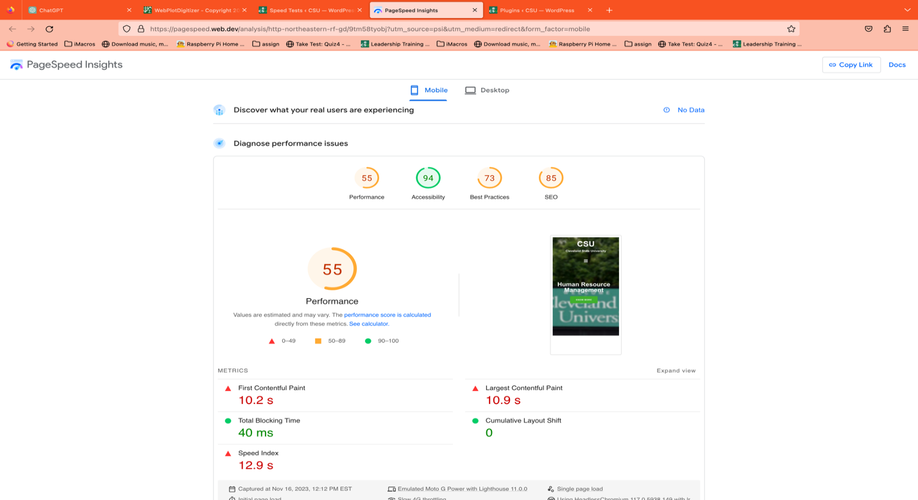

Figure 17. TC031 Results Part 1

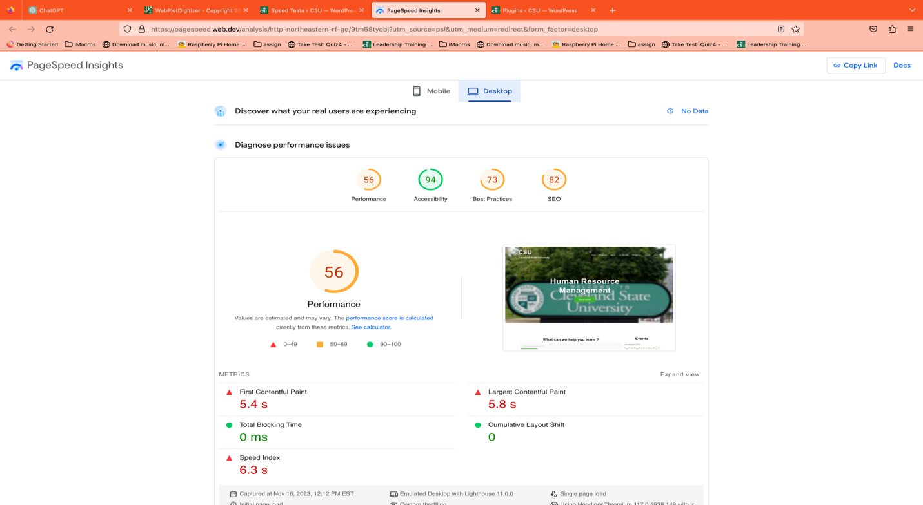

Figure 18. TC031 Results Part 2

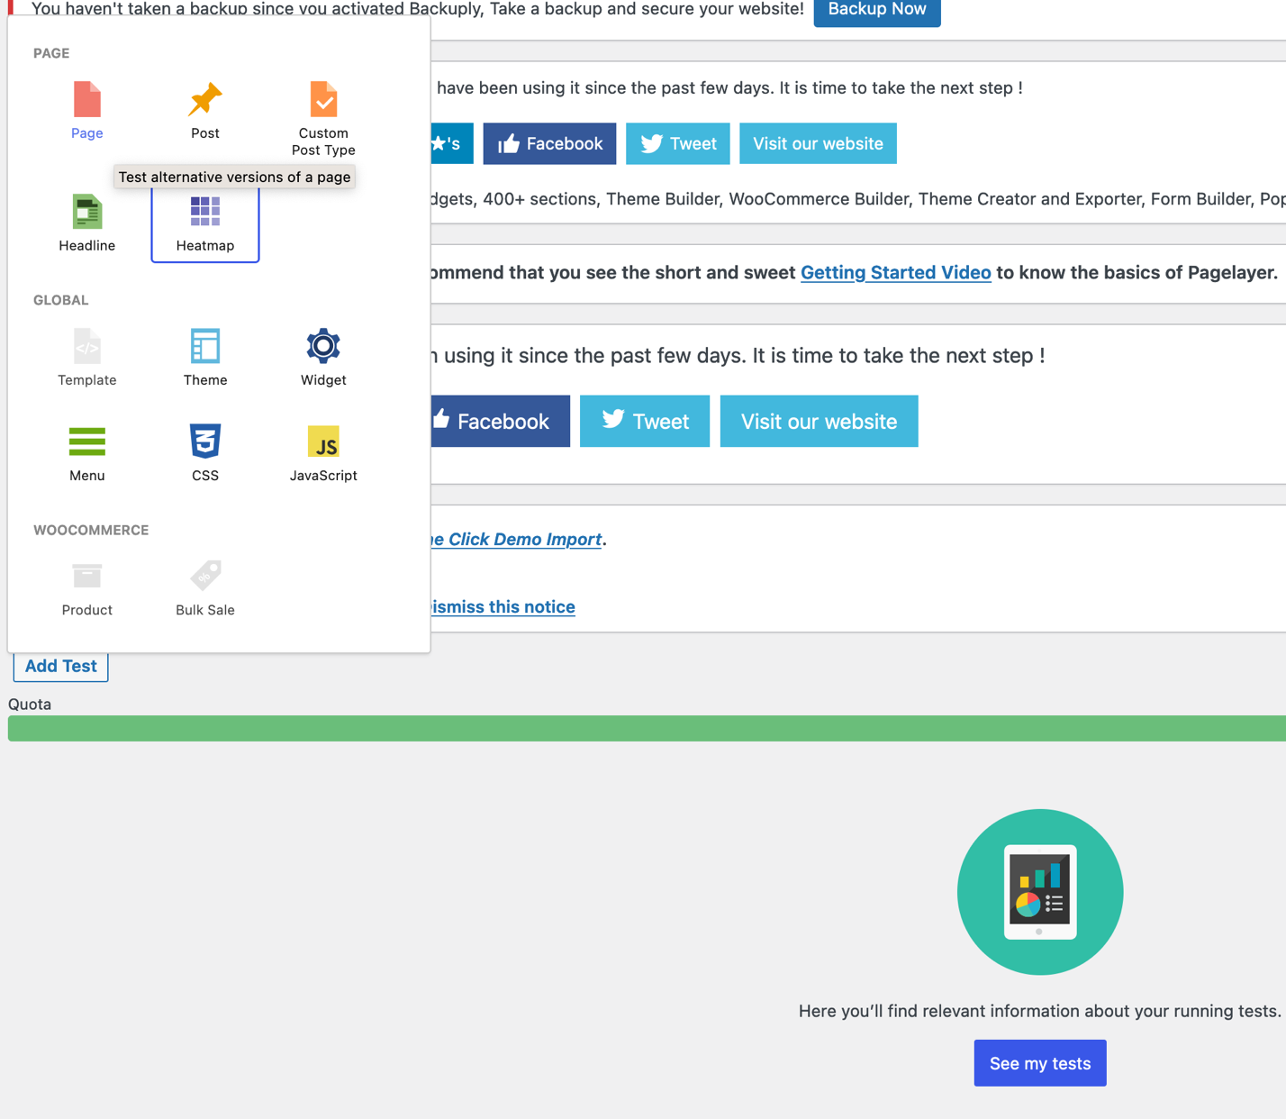

Figure 19. TC032 Results

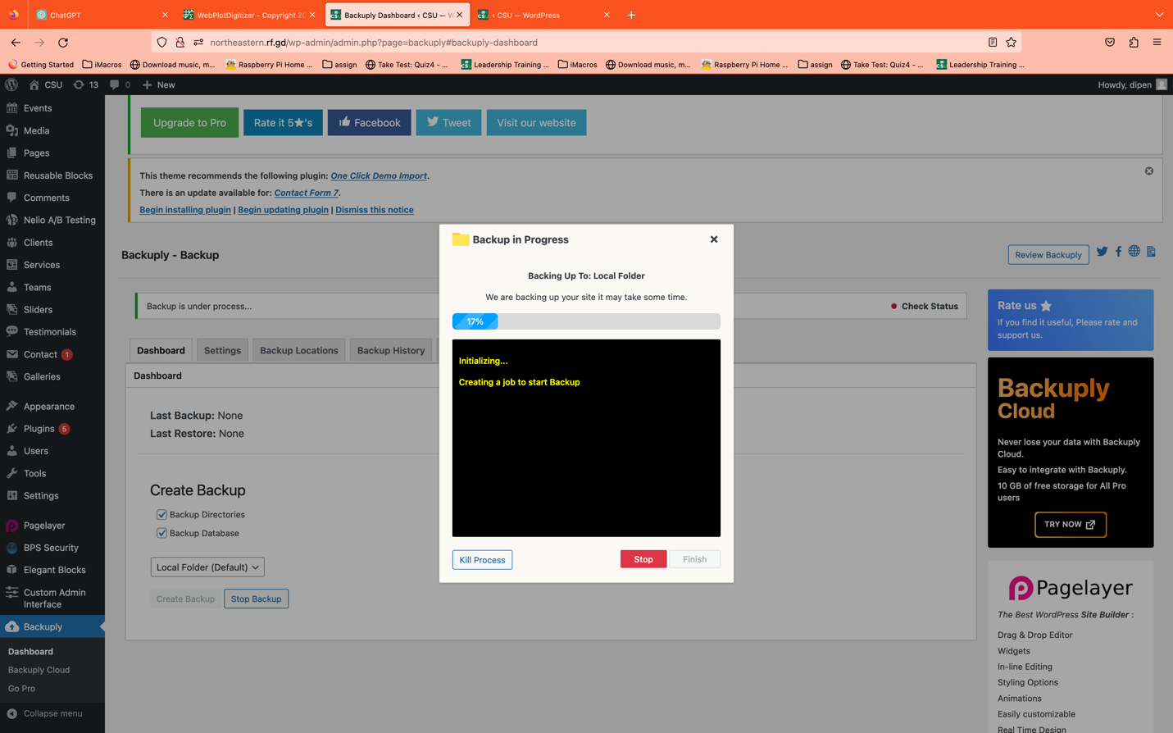

Figure 20. TC033 Results

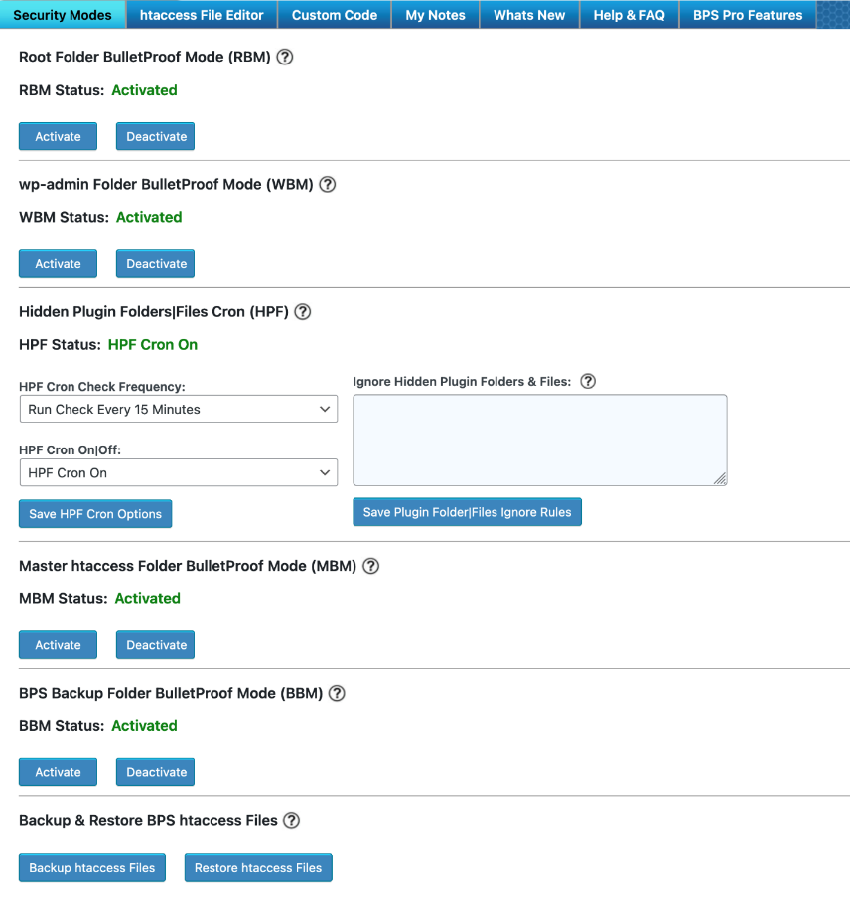

Figure 21. TC034 Results

Figure 22. TC035 Results Part 1

Figure 23. TC035 Results Part 2

Figure 24. TC036 Results

All the test cases for the HRM system were conducted meticulously to ensure the reliability, functionality, and performance of the application. The comprehensive test suite covered a wide range of use cases, addressing both user-facing functionalities and backend processes. The primary focus was on validating critical scenarios, such as user login and registration, employee enrollment, leave request and approval processes, as well as the management of employee details and payroll. Additionally, the testing strategy incorporated scenarios related to the HRM system's compatibility across different devices, browsers, and screen resolutions. By employing techniques like Equivalence Partitioning and Boundary Value Analysis, the test cases were designed to provide exhaustive coverage, identifying potential vulnerabilities and ensuring the robustness of the system. Despite the rigorous testing approach, the assessment revealed a notable performance issue related to slow website speed, attributed to the limitations of the free hosting service. This finding underscores the importance of a comprehensive test strategy that not only validates functional requirements but also considers non-functional aspects like performance. The test assessments aim not only to identify defects but also to provide actionable insights for continuous improvement. Recommendations have been made to address the performance issue, emphasizing the need for performance testing, consideration of alternative hosting solutions, and the implementation of optimization techniques. The results of the test assessments serve as a foundation for iterative refinement and enhancement, contributing to the overall quality and user satisfaction of the HRM system.

## **6.5. Defects reports**

Performance Issue – delay in speed: The HRM system hosted on free hosting experiences, which is infinite free that leads to slow website speed.

* Issue Description:
* The website response time is kind of slow, impacting the overall user experience.
* Loading of pages, especially those with complex content or numerous resources, takes some amount of time.
* Users may face delays in accessing critical functionalities, affecting productivity and satisfaction.
* Environment:
* Hosted on free hosting service which is infinite free.
* Testing conducted on various browsers, including Google Chrome, Mozilla Firefox, Edge, and Safari.
* Expected Behavior:
* The website should load within an acceptable time frame, providing a seamless and responsive user experience.
* Resource-intensive operations should be optimized to avoid delays.
* Observed Behavior:
* Loading times are significantly slower than acceptable standards.
* Resource-intensive operations, such as accessing the database or generating reports, exacerbate the performance issue.
* Impact: The delay in the website speed negatively impacts user experience, potentially leading to frustration among users. It may also hinder the efficiency of HR managers and employees relying on the system for time-sensitive tasks.
* Priority: This issue is of high priority due to its direct impact on user experience and system usability.
* Recommendation: Consider Alternative Hosting: Evaluate the possibility of migrating to a more robust hosting solution, considering the system's resource requirements.

# **7. Conclusion**

The HRM Panel project has successfully achieved its goals, modernizing and enhancing Cleveland State University HR system. Lessons learned highlight the importance of stakeholder collaboration, iterative development, and proactive security measures. Future development focuses on continuous improvement, incorporating user feedback, exploring emerging technologies, and maintaining a secure and adaptive system.

## **7.1. Outcomes of the project**

The conclusion of the Human Resource Management Panel (HRM) project marks a transformative moment for Cleveland State University, with several notable outcomes achieved. The primary goals set forth at the project's inception were to modernize and enhance the university's human resources management system through the development of a cutting-edge software solution. The HRM Panel successfully streamlined HR operations, improved data management, and contributed to the university's operational excellence. Through the integration of PHP, JavaScript, WordPress, and MySQL, the system provided a user-friendly interface for HR professionals and employees alike. The outcomes reflect a successful alignment with the project's objectives, realizing a comprehensive solution that addresses the evolving needs of the university's HR department.

## **7.2. Lessons learned**

The project journey brought forth valuable lessons that will inform future initiatives and developments. One key lesson learned is the importance of continuous stakeholder engagement. Active involvement from HR professionals, employees, and other relevant stakeholders throughout the project lifecycle contributed to a more accurate understanding of requirements and facilitated smoother implementation. Additionally, the iterative and incremental lifecycle model proved to be effective, allowing for flexibility and adaptability to changing needs. Emphasizing the need for robust data security measures and regulatory compliance early in the project ensured a more seamless integration of these critical aspects. Collaboration with the university's IT department was instrumental, highlighting the significance of aligning technical infrastructure with project goals. These insights will guide future projects, emphasizing the significance of stakeholder collaboration, iterative development, and proactive consideration of security and compliance measures. Overall, the lessons learned during the HRM project will serve as a foundation for continuous improvement and success in future endeavors.

## **7.3. Future development**

Looking ahead, the conclusion of the HRM project paves the way for future development, building upon the success and insights gained. Future development will focus on introducing new features and functionality to enhance the HRM Panel, responding to evolving needs and technological advancements. Priorities include continuous user feedback integration, exploration of emerging technologies, mobile accessibility optimization, and scalability and performance optimization. Ongoing efforts will be invested in reinforcing security measures, maintaining a proactive stance against cybersecurity threats. Training and support programs will be sustained to empower users, and collaboration with external systems will be explored to foster an integrated digital ecosystem. The future development roadmap ensures that the HRM Panel remains a dynamic and adaptive solution, continually meeting the evolving needs of Cleveland State University HR department and contributing to the university's commitment to operational excellence.

# **References**

Bootstrap. (2023). Bootstrap Documentation. Retrieved from https://getbootstrap.com/docs/5.3/getting-started/introduction/.

InfinityFree. (2023). Free Web Hosting with Unlimited Disk Space, Unlimited Bandwidth and Unlimited Websites from InfinityFree. Retrieved from https://www.infinityfree.com/.

Mozilla Developer Network. (2023). JavaScript Reference. https://developer.mozilla.org/en-US/docs/Web/JavaScript.

MySQL. (2023). MySQL. https://www.mysql.com/

PHP. (2023). PHP: Hypertext Preprocessor. https://www.php.net/

Snook, J., Smith, S., Bolton, J., Adams, C., & Johnson, D. (Year of publication not available). The Art and Science of CSS. ISBN 10: 0975841971 / ISBN 13: 9780975841976.

WordPress.org. (2023). About WordPress. WordPress.org. https://wordpress.org/about/.